OET Medicine Writing Week

Molly Smith

The task is: Write a letter to a healthcare professional requesting continuation of care for a patient. (sometimes providing an update)

Planning

10 - 15 minutes:

- Find the purpose
- Identify the case notes you will use
- Organise the case notes into logical paragraphs

What is the situation after the above steps?

I can focus on writing = Perfect circumstances in which to write a letter

-------------------------------------------------------------------------------------------------------------------

Identifying Purpose & Choosing Case Notes:

Ask yourself these questions about Molly Smith case notes:

- Who is the reader? | plastic surgeon
- What is the reader’s task? | urgent investigation, definitive diagnosis and management
- Does the reader know the patient? | yes
- Does the writer have any tasks? | No
- Why am I writing today? | suspect sepsis
- Is it urgent? | yes

Case Notes

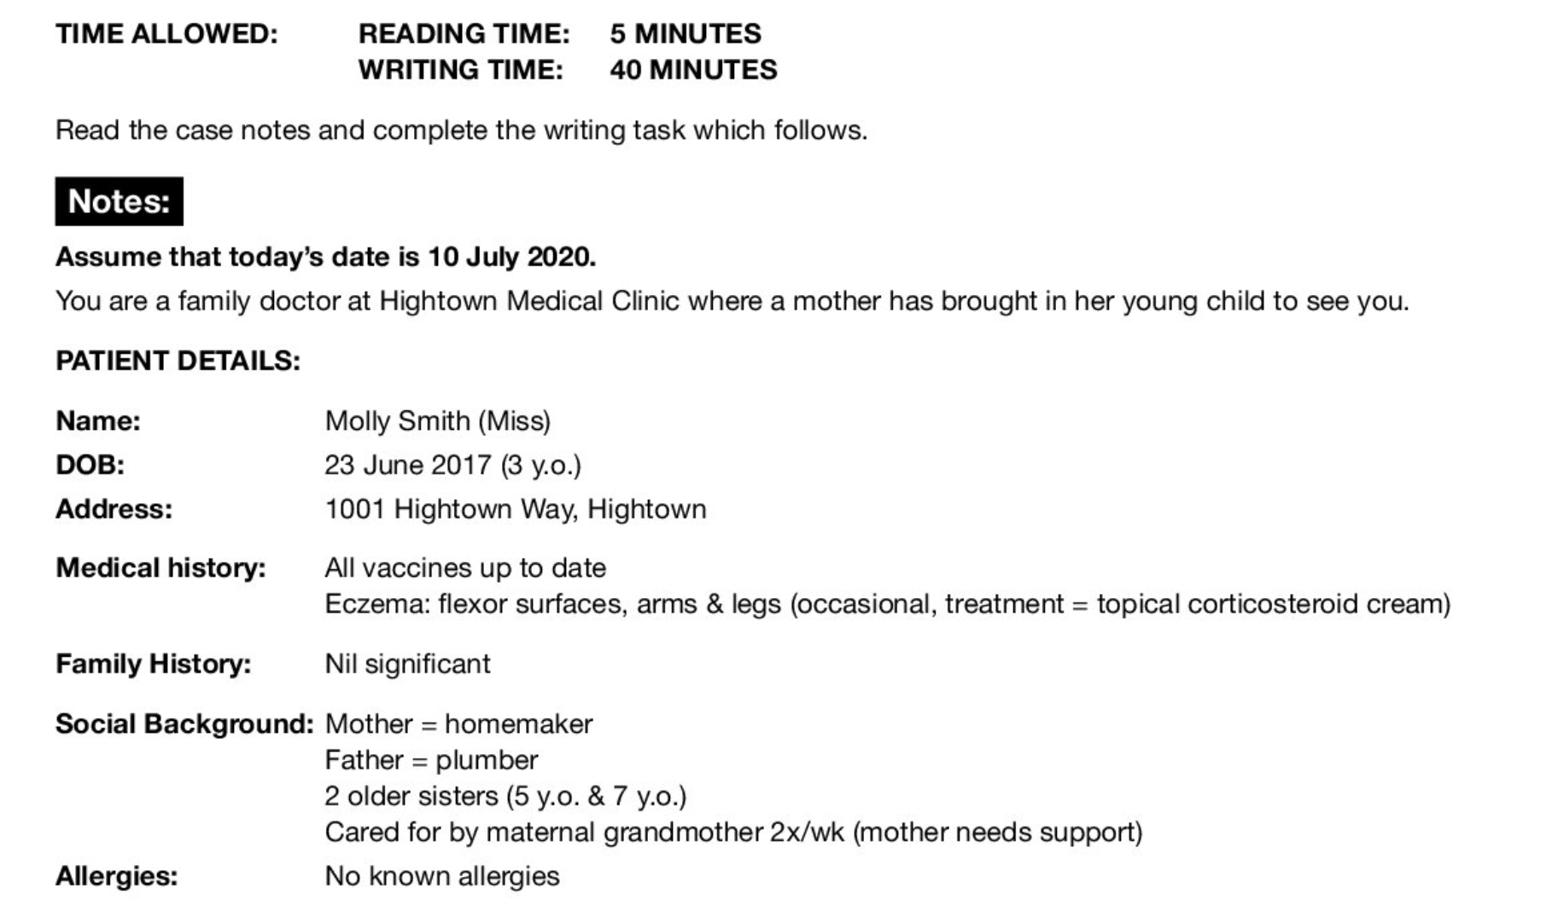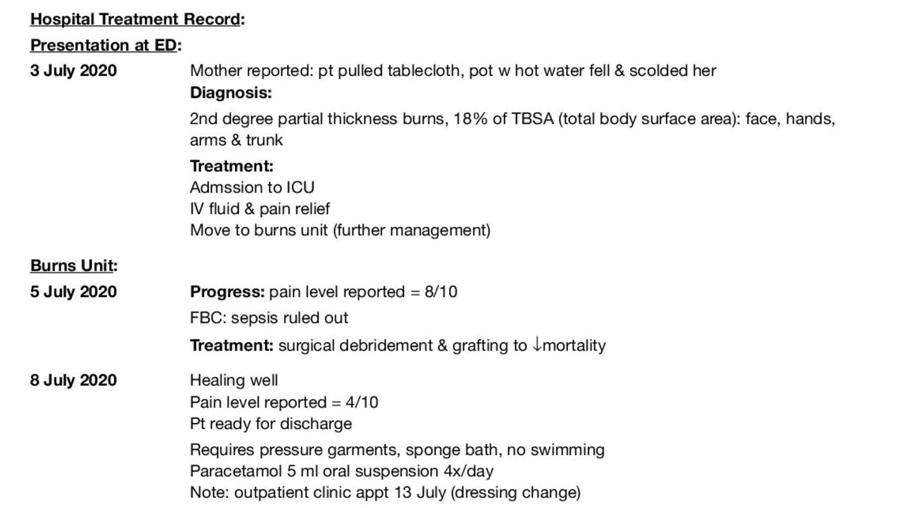

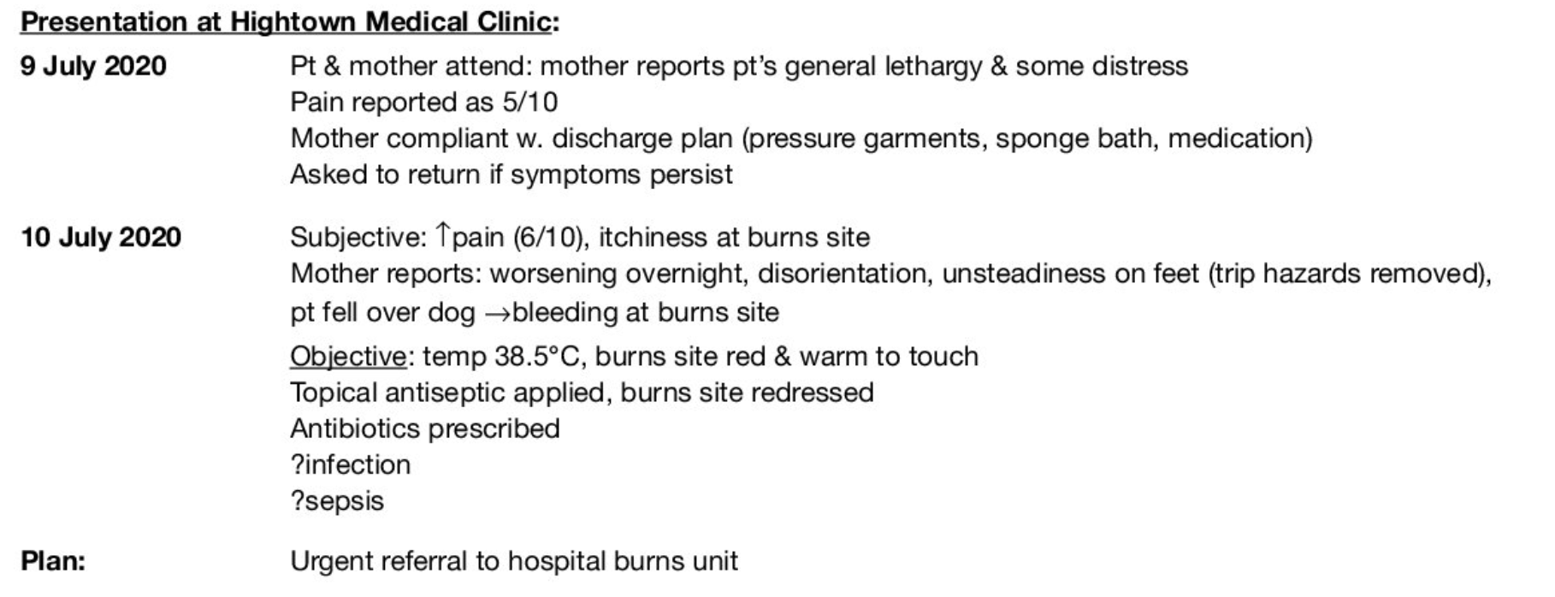

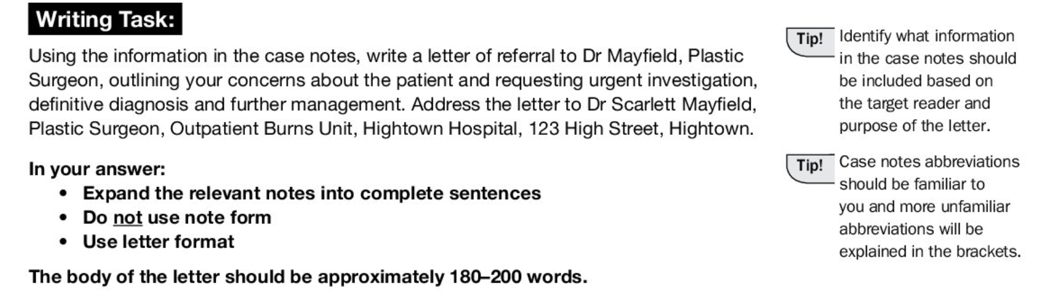

Link: https://www.dropbox.com/scl/fi/8dt5sxpczbwn8j8ec0vcb/Molly-Smith-Case-Notes.pdf?rlkey=979zf5qbspyqzq3o254zj5ia5&dl=0

Paragraph Plan

Make a paragraph plan using the planning and discussions in class, using any of the below paragraph functions:

Introduction | - Patient name:  - General Medical Context:  - General Request:
Early Timeline | Summarise:  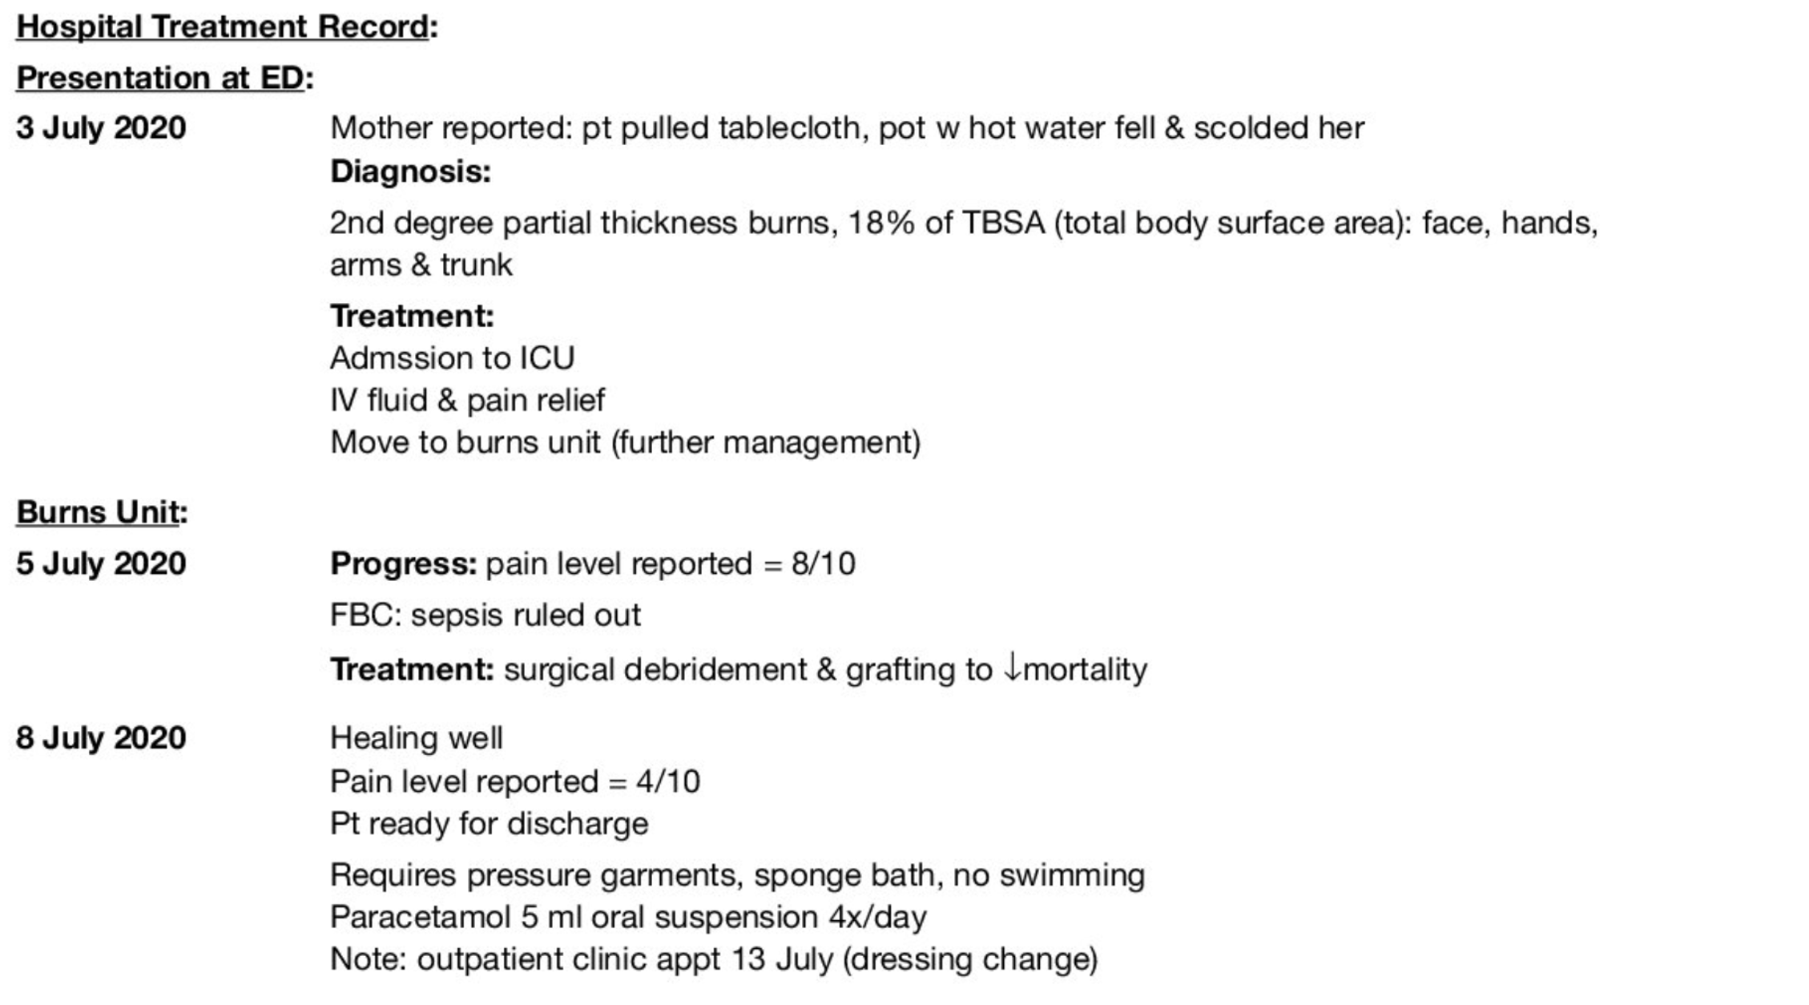
Current (9th & 10th July) | 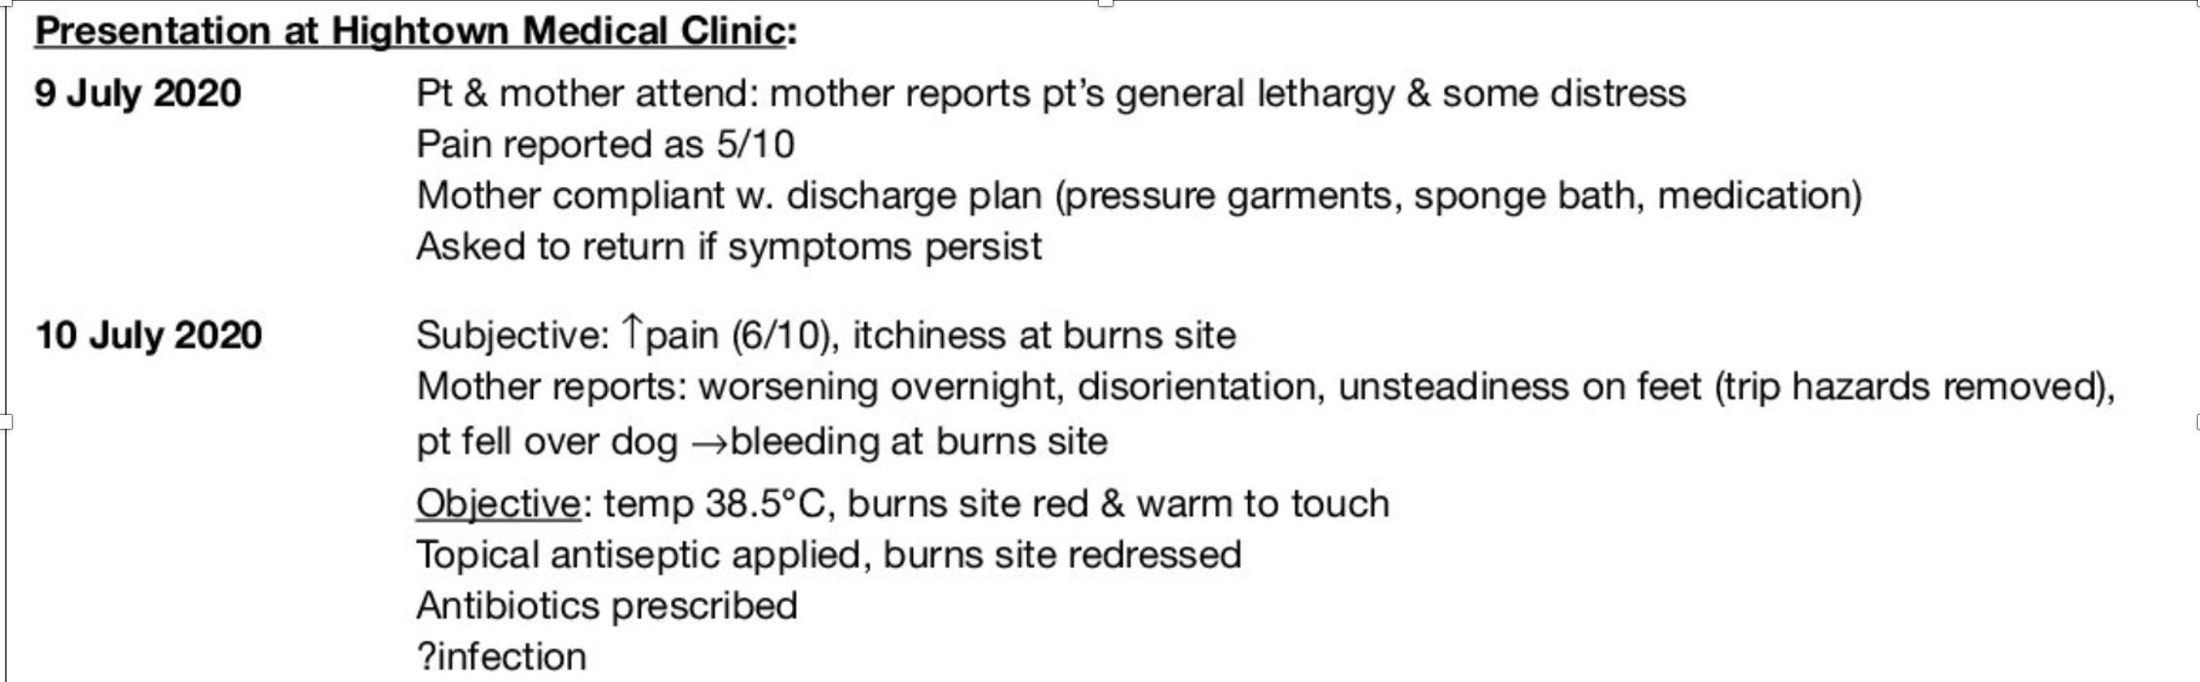
Request | Expand on the purpose:

Homework: Send introduction to paul@set-english.com

