TODAY: Introduction to OET Writing

- OET Criteria
- Paragraphing
- Letter Layout

What are the OET Writing Criteria?
Scoring method

In OET there are 6 criteria:
- Purpose
- Content
- Conciseness and Clarity
- Genre and Style
- Organisation & Layout
- Language: grammar, vocab, punctuation, etc.

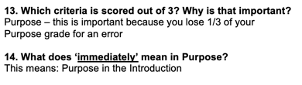
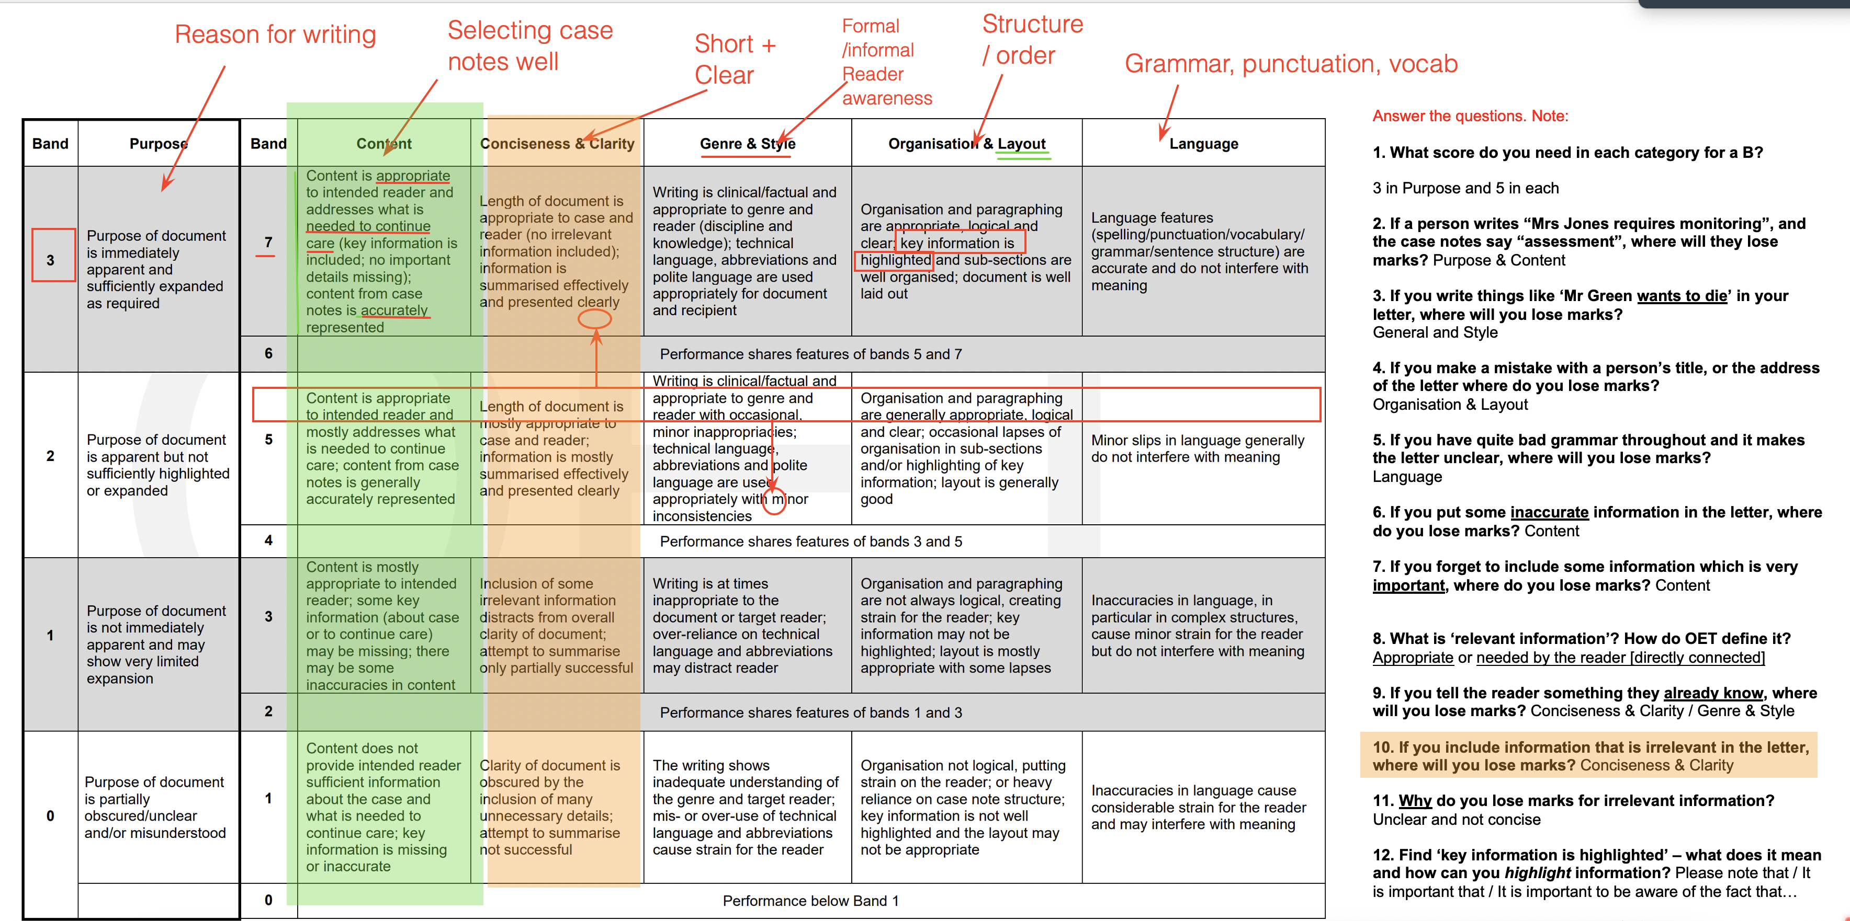

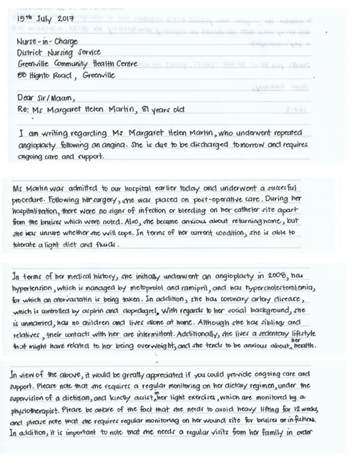

PARAGRAPHING

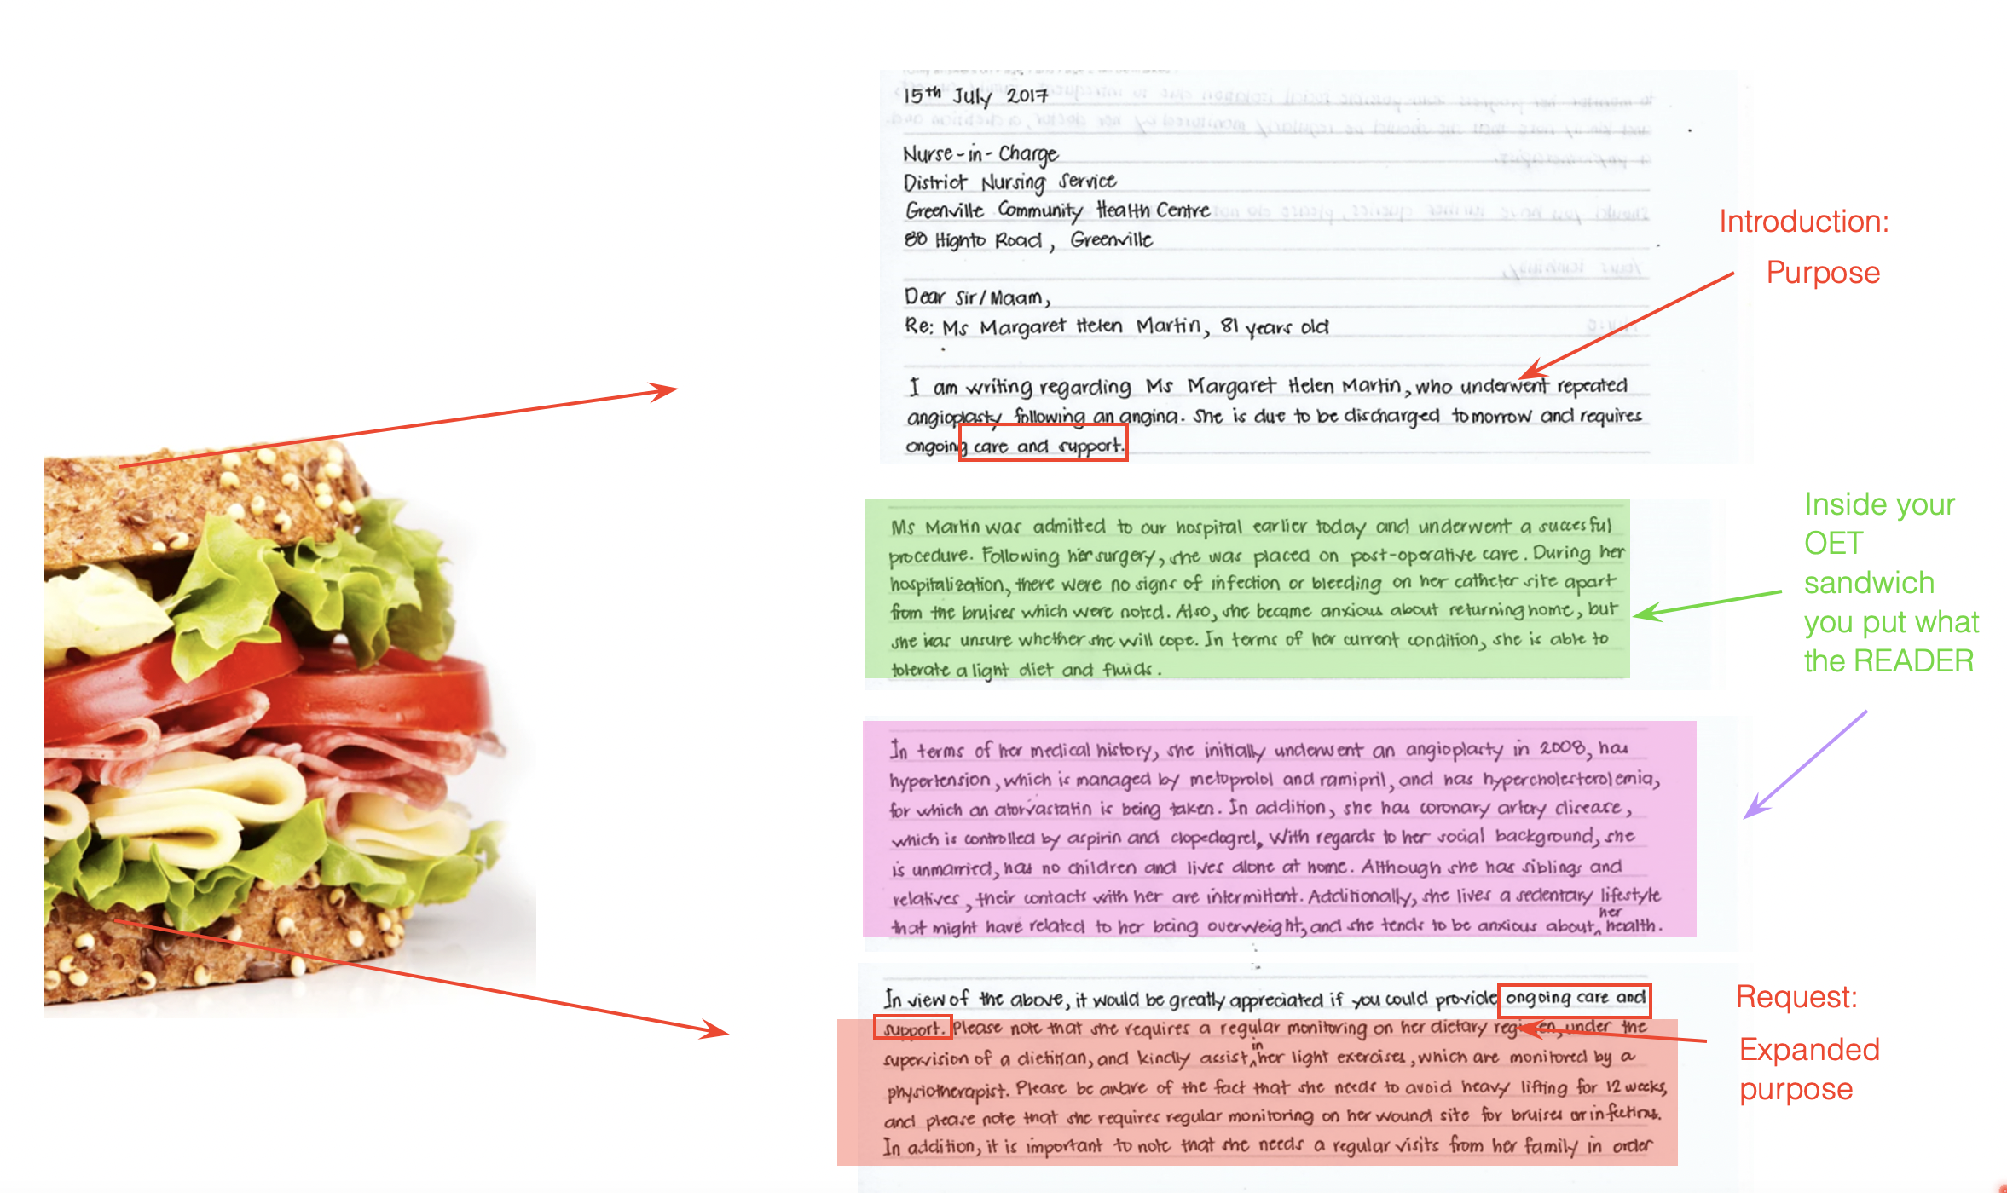

‘Filling’ = what you put inside a sandwich

MOST COMMON PARA TYPES:

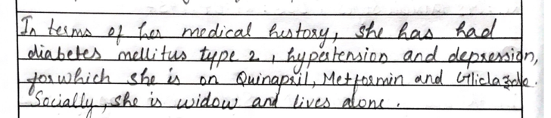 | Background: past medical history / social history  Not directly related to the case. (Appropriate information)  It is a thematic paragraph: there is no sequence. Its just all related to the topic of social or medical history  Relax structure and tenses a little. It doesn’t matter order.
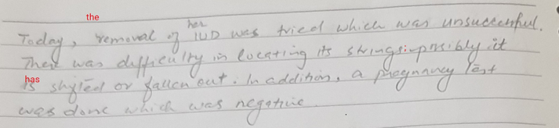 | Current condition: situation now  I just want to tell reader wat is TRUE about the patient.
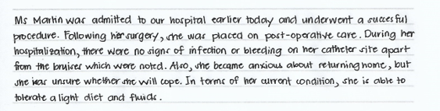 | Timeline paragraph: narrative paragraph.  Grammar is more difficult.  Sequence is important.

Are these the only fillings for your OET Sandwich?

No!

Other possible ideas:

Medication paragraph
Diagnostic paragraph
Appointments paragraph

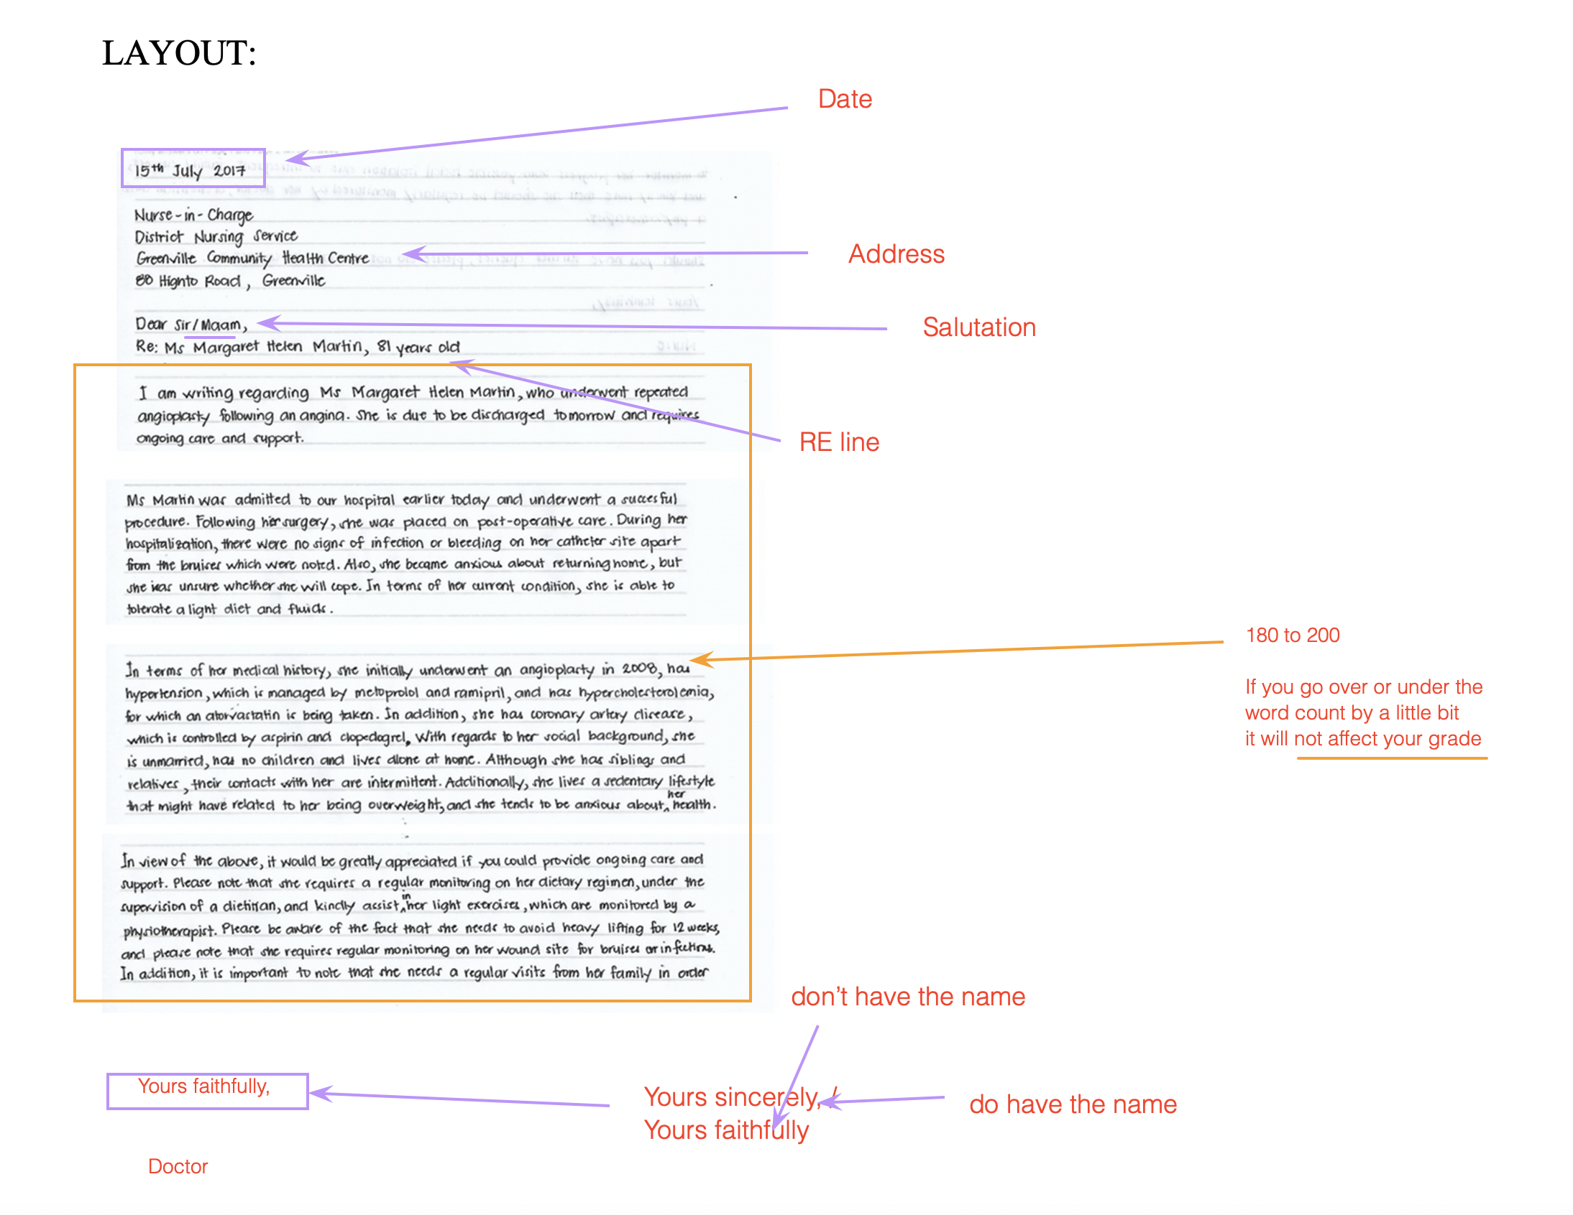

Tomorrow:

- We will analyse a set of case notes and plan our letter

- Want to see the case notes early? You can download them below the video tonight.

